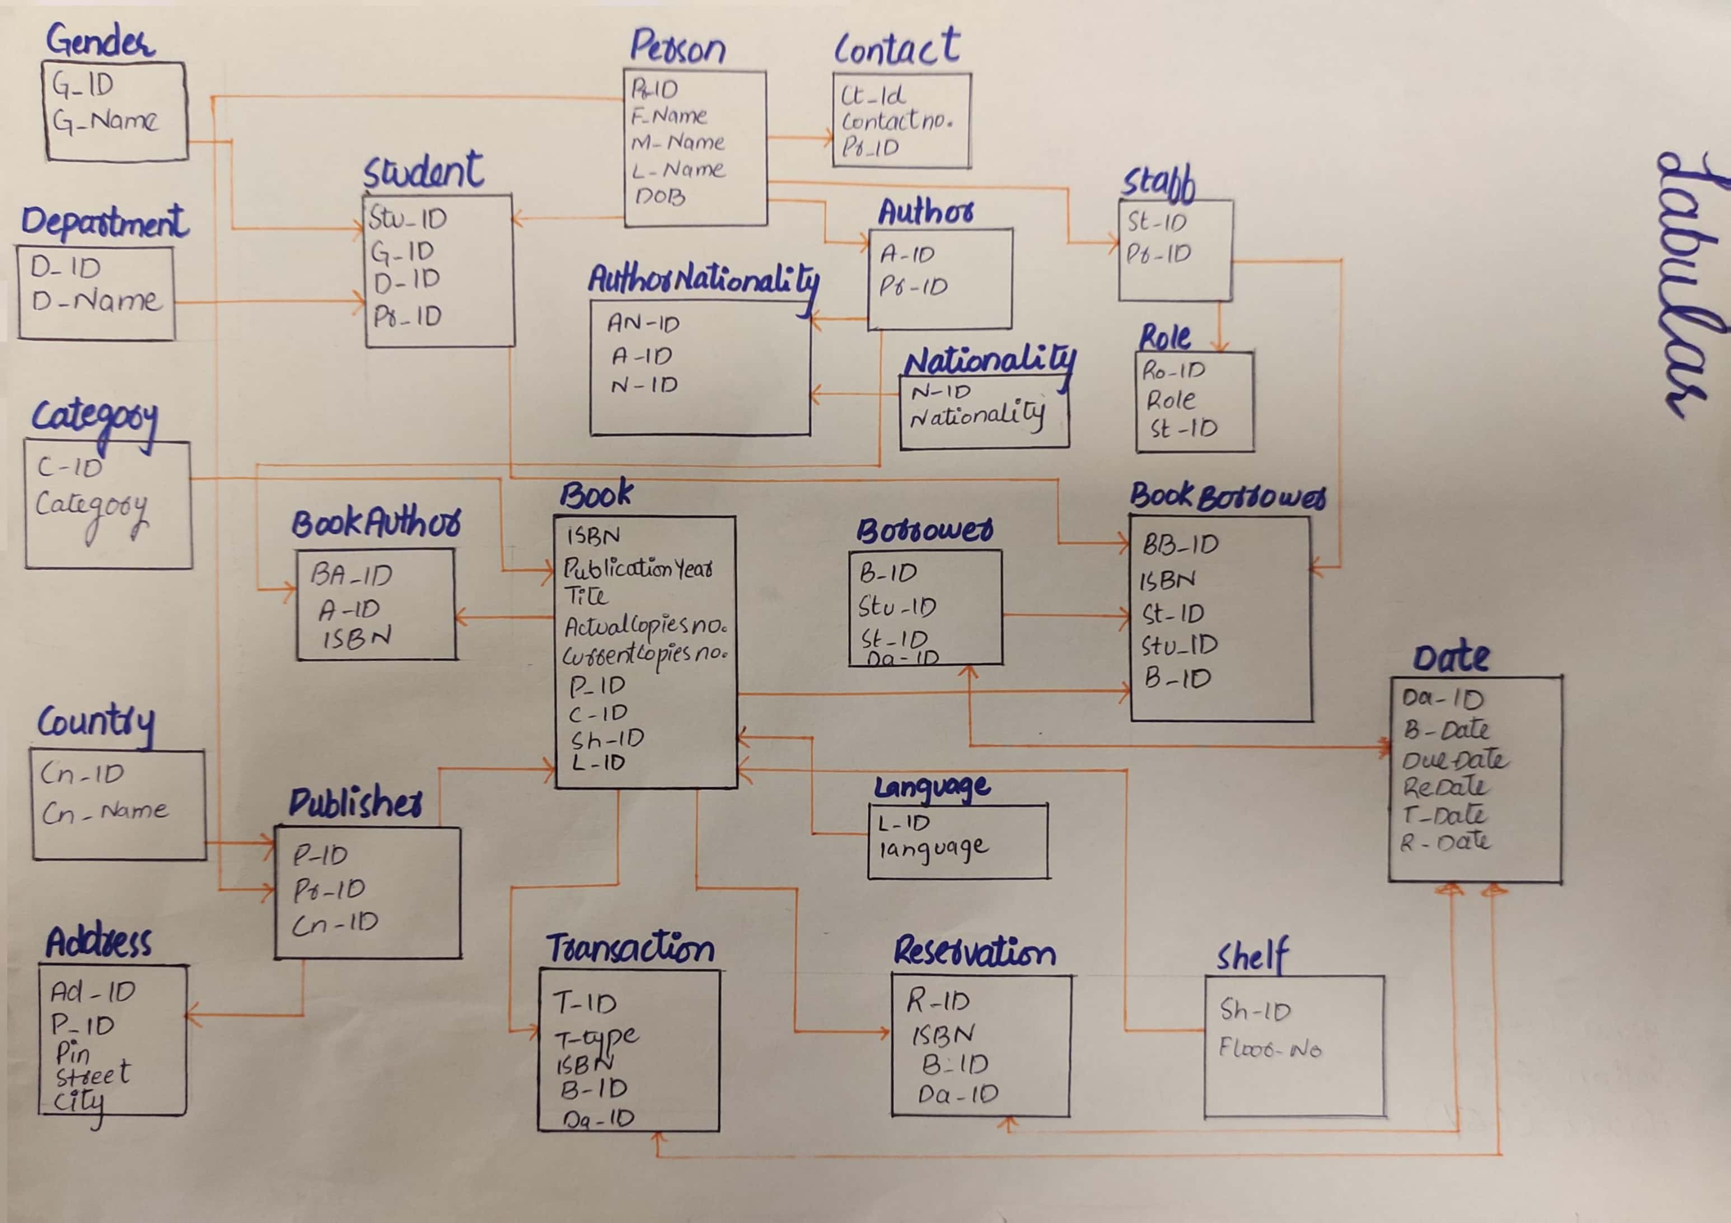

[CamScanner](https://v3.camscanner.com/user/download)

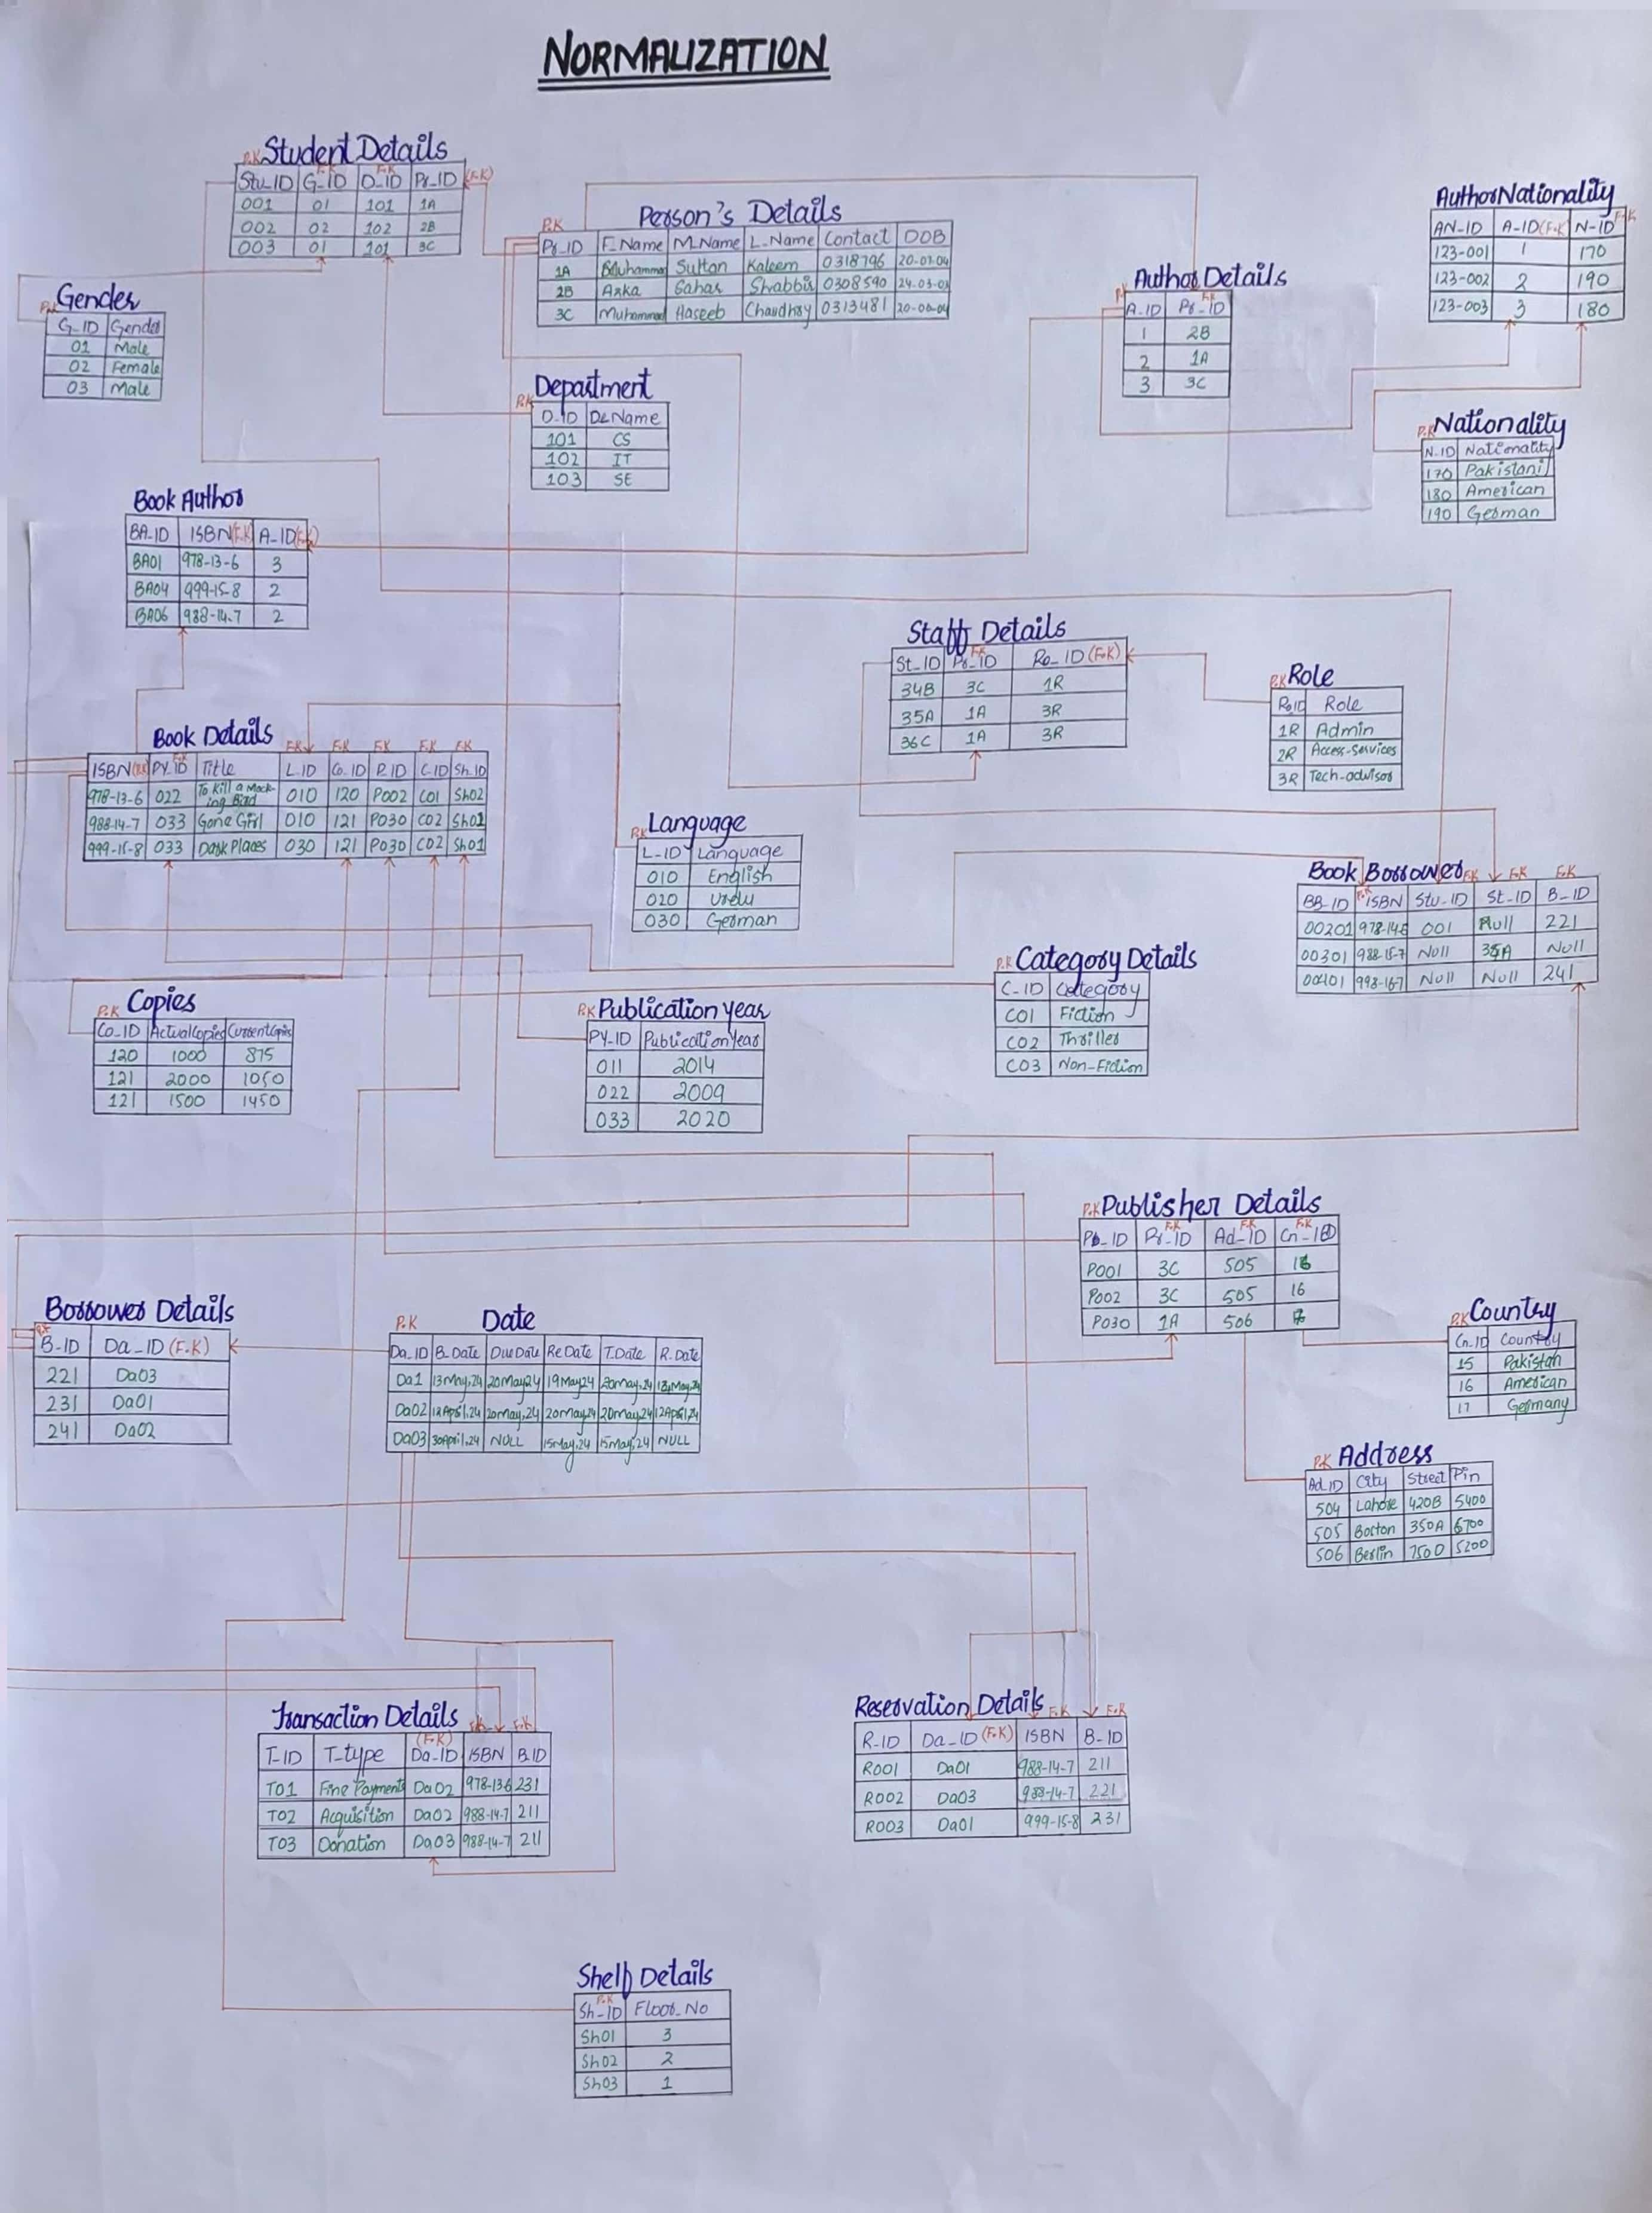

[CamScanner](https://v3.camscanner.com/user/download)

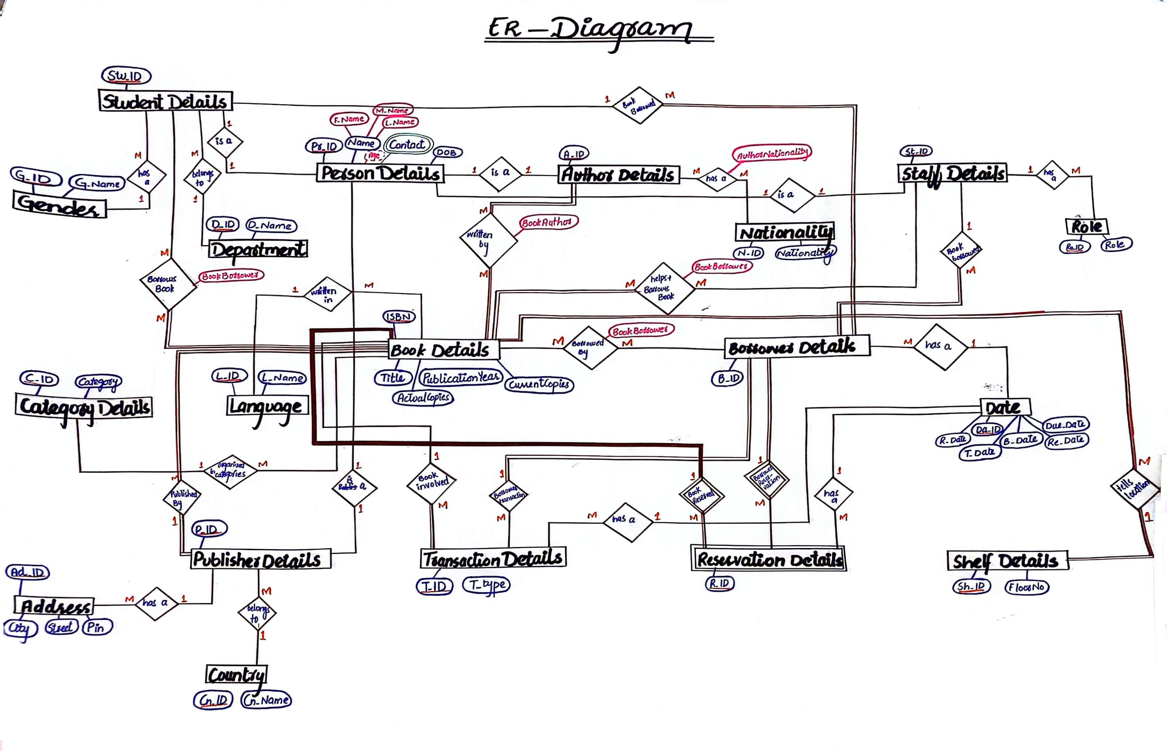



[CamScanner](https://v3.camscanner.com/user/download)